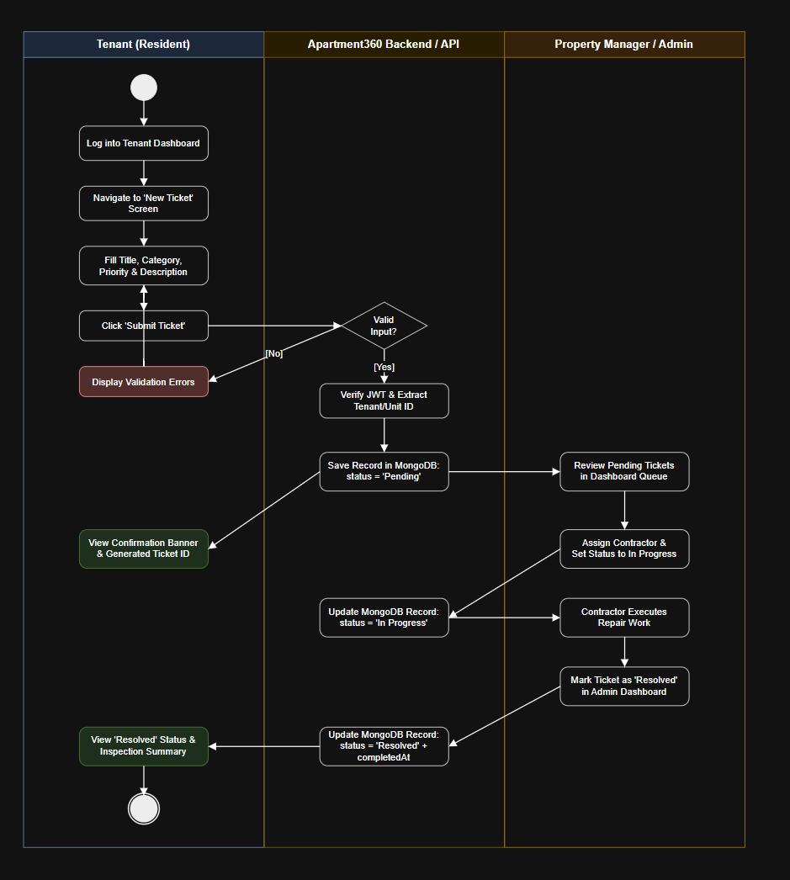
Activity Diagram Specification: Maintenance Request & Resolution Lifecycle
Project Name: Apartment360 – Apartment Housing Management System
Mapped Workflow: UC-04 (Submit Maintenance Ticket) & UC-05 (Update Ticket Status)
Document Version: 1.0
1. Swimlane Architecture & Overview
The Activity Diagram models the dynamic operational flow and decision-making logic of the system across three distinct swimlanes (partitions):
- Tenant Swimlane: Captures user actions from ticket drafting to reviewing resolution.
- System / Backend Swimlane: Enforces data validation, JWT authentication, and MongoDB persistence.
- Property Manager / Admin Swimlane: Details triage, staff assignment, and maintenance resolution workflows.
2. UML Activity Diagram (Mermaid)
Code snippet
flowchart TD
subgraph Tenant["Tenant (Resident)"]
A([● Start]) --> B[Log into Tenant Dashboard]
B --> C[Navigate to 'New Ticket' Screen]
C --> D[Enter Title, Category, Priority & Description]
D --> E[Click 'Submit Ticket']
N[Display Validation Errors] --> D
J[View Confirmation Banner & Ticket ID]
S[View Status Update & Verified Resolution]
S --> T([◉ End])
end

subgraph System["Apartment360 Backend / API"]
E --> F{All Fields Valid?}
F -- No --> N
F -- Yes --> G[Verify Active JWT & Extract Tenant/Unit ID]
G --> H[Create MongoDB Record: status = 'Pending']
H --> J
H --> K[Push Notification / Update Admin Queue]
P[Update Record in DB: status = 'In Progress']
R[Update Record in DB: status = 'Resolved' & add completedAt]
end

subgraph Admin["Property Manager / Admin"]
K --> L[Review Pending Tickets in Admin Dashboard]
L --> M[Assign Maintenance Contractor & Set Priority]
M --> P
P --> Q[Contractor Executes Repair Work]
Q --> O[Mark Ticket as 'Resolved' in Dashboard]
O --> R
end

R --> S
3. Action State & Decision Node Breakdown
Step / Node | Swimlane | Node Type | Description
Start Node | Tenant | Initial State | Tenant accesses the Apartment360 web portal.
Draft & Submit Form | Tenant | Action State | Tenant populates the maintenance form with issue details and priority level.
Input Validation | System | Decision Node | Verifies non-empty fields and length limits; branches to display errors if invalid.
Create Ticket Record | System | Action State | Saves ticket into MongoDB with an initial status of Pending and stamps current timestamp.
Review & Triage | Admin | Action State | Admin reviews incoming requests in the dashboard queue and assigns personnel.
Update to In Progress | System | Action State | Database record changes from Pending $→$ In Progress.
Execute Repair | Admin | Action State | Physical repair is performed on-site by maintenance staff.
Mark Resolved | Admin | Action State | Admin updates ticket state to Resolved with resolution notes.
Close & Review | Tenant | Action State | Tenant receives updated status confirmation; workflow terminates at Final State.

